**1. show file system**

$ df –h

**2. show hard disk information**

$ lsblk

**3. hard disk operation. EX: partition, …**

$ sudo –s // root

$ cfdisk // go to reference content step by step

$ exit // leave root

Reference:

<https://askubuntu.com/questions/116351/increase-partition-size-on-which-ubuntu-is-installed>

**4. mount the folder or path to hard disk to use**

$ mkfs.ext4 /dev/sdb4 // make the ext4 fs format for this partition

$ mkdir /mnt/tmphome // make folder to be mount

$ mount /dev/sda4 /mnt/tmphome // mount the folder

$ lsblk // show the fs information, MP1 folder mount to sda3

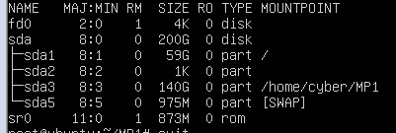

Reference:

<https://linuxize.com/post/how-to-mount-and-unmount-file-systems-in-linux/>

5. mount folder with hard-disk permanently

$ sudo -s

$ vim /etc/fstab // make the ext4 fs format for this partition

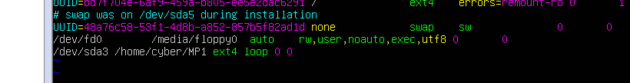

$ reboot

Reference:

<https://unix.stackexchange.com/questions/251375/mounted-dir-disappears-after-restart>

6. 網路芳鄰掛載權限

檔案權限

<https://www.opencli.com/linux/chmod-command>

<https://www.itread01.com/content/1523008588.html>